##### LEGEND BLUE

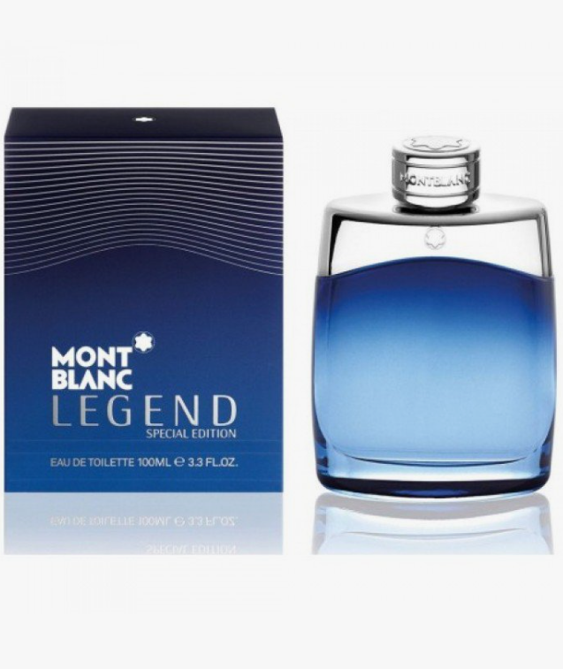**Legend Special Edition 2014** by **Montblanc** is a Aromatic Fougere fragrance for men. **Legend Special Edition 2014** was launched in 2014. The nose behind this fragrance is Olivier Pescheux. Top notes are Lime and Mint; middle notes are Apple, Violet Leaf and Cardamom; base note is Woody Notes.

Montblanc launches Legend and Legend Pour Femme Special Edition for 2014 - new, limited editions of the original Legend from 2011 and Legend Pour Femme from 2012.

Legend Special Edition 2014 is a refreshed version of the original designed for the summer season. Created by Olivier Pescheux, the composition begins with lime from Peru and fresh mint from Morocco that lead to the heart of violet leaf, sour apple and sweet cardamom. The base contains raw wood accords.

Legend is available as 100 ml Eau de Toilette.